April 17 – April 23

Science After Hours: Adult Night at the Museum / Fri April 17

Wander the museum at your own pace with a drink in your hand and drop by hands on stations that will surely rekindle your childhood curiosity. 6pm Buffalo Museum of Science, 1020 Humboldt Parkway, Buffalo, NY 14211 / 716-896-5200 / https://tinyurl.com/msv7mjnk

Disney in Concert: A Dream Is A Wish / Sat April 18
A Dream Is A Wish transports audiences into the world of classic and contemporary Disney Animated feature films to discover that dreams really do come true. Featuring orchestral scores performed by the Buffalo Philharmonic Orchestra. 7:30pm. Kleinhans Music Hall, 3 Symphony Circle, Buffalo, NY 14201 / 716-885-5000 / https://tinyurl.com/2552bcmp
Buffalo Trading Card Con / Sun April 19
This unique and exciting convention will feature over 100 vendors from all over WNY. Also included are tables to play your favorite trading card games and video game setups.10:00am – 3:00pm The Powerhouse, 140 Lee Street, Buffalo, NY 14210 / 716-878-8211 / https://tinyurl.com/wtux82t6

Open Mic Night @ Nietzsche’s / Mon April 20
Songwriter showcase and Buffalo’s Longest-Running Open Mic Nite. Everything from music, poetry to comedy. 8:00pm. Nietzche’s, 248 Allen Street., Buffalo, NY 14201 / 716-768-8927 / https://tinyurl.com/yn8ff8cv
Reaching for the Skies: The Tall Buildings Tour / Tue April 21
Take a tour of downtown with Explore Buffalo as they focus on the Tall Buildings from City Hall to Seneca One Tower and more. 10:00am Tour meets on Pearl @ Seneca Street, Buffalo, NY 14202 / 716-245-3032 / https://tinyurl.com/vjh65pnf
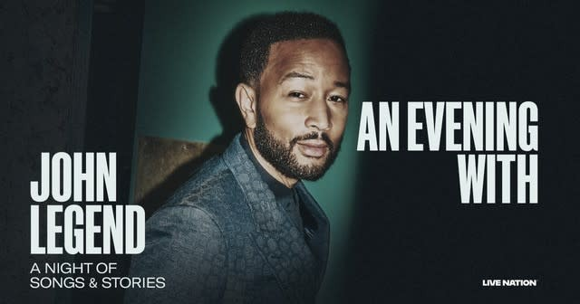 John Legend “A Night of Songs and Stories” / Wed Apr 22
Multi-platinum, 13-time Grammy Award-Winner John Legend brings ‘A Night of Songs and Stories’ to Shea’s Buffalo! 8:00pm Shea’s Buffalo, 646 Main Street, Buffalo, NY 14202 / 716-847-0850 / https://tinyurl.com/yrtmsry

Buffalo Bisons vs. Columbus / Thu Apr 23
Grab a hot dog, some Cracker Jack and settle in for an exciting night of baseball.5:05pm Sahlen Field, 1 James D. Griffin Plaza, Buffalo, NY 14203 / 716-843-4373 / https://tinyurl.com/3jjezs99

